INTRODUCTION
This technical report aims to detail the construction and outcomes of statistical models designed to estimate sales at a GroceryPlus store, analyze advertising and promotion interactions for BikeMart, predict customer behavior for Gadget4U, assess store manager turnover at CosmeticChain, and forecast production volumes for a pale ale product. Each task utilizes specific analytical techniques to answer business questions, offering insights and strategic guidance based on robust statistical evidence.
FINDINGS
- GroceryPlus Model Building
To predict GroceryPlus sales revenue, a multi-regression model is developed. Scatter plots and correlation matrix are used to identify potential predictors and multicollinearity. Wages', 'No. Staff', 'Advertising Expense', and 'Car Spaces' show moderate to strong relationships with Sales (0.813, 0.737, 0.842, 0.571 respectively). High correlations are found between 'No. Staff' and 'Wages' (0.925), ‘Union%’ and ‘Age’ (0.889), and ‘Hours Trading’ and ‘Competitors’ (0.967) leading to the removal of 'No. Staff', ‘Union%’, and ‘Competitor’ to reduce redundancy.
The initial model including 8 predictors show overall predictive power (p < 0.05). Iterations remove insignificant predictors sequentially based on t-tests: Mng-Gender, HrsTrading, Sundays, and Age (p-value > 0.05). The final model retains 4 significant predictors: Wage, Advertising Expense, Car Spaces, and Home Delivery.
Residual plots are examined to ensure no violation of regression assumptions (Refer to Apendix A).
Model Performance:
- R-Square: 0.80 (80% of Sales Revenue variability explained, thus this model demonstrates strong explanatory power).
- Adjusted R-Square: 0.79, indicating good model fit.
- Intercept: 1.27 (revenue with other predictors at 0 is $1.27m).
- Wages (coefficent: 2.15): assuming other predictors are constant, for a unit increase in wages, on average, sales revenue increase by $2.15 million.
- Advertising Expense (coefficient: 0.03): assuming other predictors are constant, for a unit increase in advertising expense, on average, sales revenue increase by $0.03 million.
- Car Spaces (coefficient: 0.02): assuming other predictors are constant, for a unit increase in car spaces, on average, sales revenue increase by $0.02 million.
- Home Delivery (coefficient: 1.51): assuming other predictors are constant, for one more home delivery, on average, sales revenue increase by $1.51 million.
The model has strong predictive power with 80% of Sales Revenue variability explained, effectively identifying key determinants. It provides insights into strategic areas like advertising and service offerings, informing management decisions to optimize sales performance and operational efficiency.
- BikeMart’s Interaction Effect
The regression model demonstrates strong predictive power with an R-square of 0.90 and a highly significant F-statistic.
Coefficient analysis:
- Advertising Spend (2.52, p=0.02): Significant, indicating that, assuming no change in other predictors, for a unit increase in advertising expenditure,on average, sales revenue increases $2.52.
- Promotions (-812.98, p=0.12): Not significant, suggesting no clear independent impact on sales revenue.
- Interaction Term - Advertising*Promotions (2.38, p=0): Significant, indicating promotions moderate the relationship between advertising expenditure and sales.
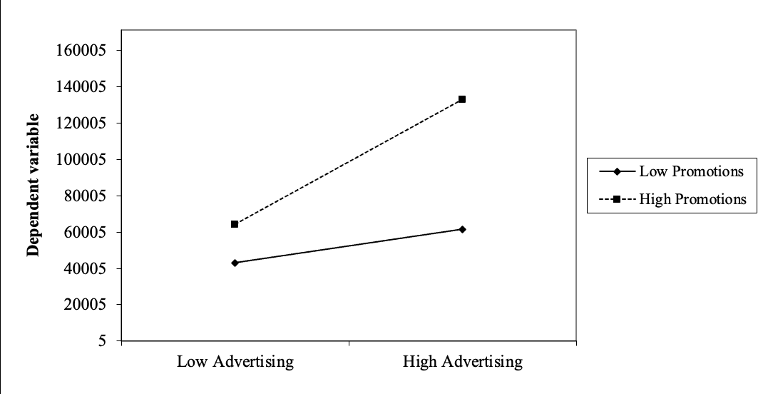
Figure 1. Interaction Term – Advertising*Promotions
Figure 1 demonstrates the interaction term:
- High promotions generate more sales than low promotions at both low and high advertising expenditure levels.
- Advertising expenditure positively affects revenue across both low and high promotions.
- The positive effect of advertising expenditure on revenue is stronger with high promotions.
- Overall, promotions moderates the relationship between advertising spend and sales, such that the relationship is significantly stronger for high promotions than for low promotions.
Recommendations:
- Consider gradually increasing the advertising budget, as it positively affects revenue regardless of promotion levels.
- Given that high promotions generate more sales for low and high advertising, allocate a substantial part of the marketing budget towards promotions, especially when combined with advertising.
- Increase both advertising and promotional budgets proportionally for potentially exponential benefits, since high advertising and high promotions generates significantly more revenue.
- Gadget4U’s Model Building
Logistic regression model is chosen to predict whether customers will buy headphones after purchasing mobile phones. The initial model with 8 predictors show overall predictive power (p-value < 0.05).
After removing insignificant variables individually (Age, Mobile Phone Brand, Email Opened, Gender, Clicked on Ad, Days Since Last Purchase) through 6 iterations based on t-test, the final model retains two predictors:
- Annual Income with coefficent of -0.01 and exp(b) of 0.99 indicates that each unit of increase in annual income decreases the odds of buying headphones by 1%.
- Previous Purchases with coefficient of 0.22 and exp of 1.25 indicates that one unit of increase in previous purchases increases the odds of buying headphones by 25%.
Model Performance:
- Pseudo, Cox and Snell, and Nagelkerke R-square are 6%, 7%, and 11% respectively, indicating low predictive power.
- Reduced log-likelihood compared to baseline, suggesting statistical significance (LL: -84.13 and LL0: -89.87).
- Overall classification accuracy: 0.72, indicating that 72% of the cases were accurately classified by the logistic regression model. The model has high accuracy for non-events (0.96) but low accuracy for events (0.12).
- Area under ROC curve: 0.68, better than random classifier (AUC of 0.5) but not excellent.
The model demonstrates a moderate level of accuracy. However, it has a low R-square value, suggesting it might not capture all the variability in the data. This model appears to be better at predicting non-events, thus it is not suitable for the purpose of Gadget4U. To improve performance, consider including more relevant variables or refining existing ones to capture data nuances. Further adjustments and testing could enhance the model predictive power.
- ComesticChain Model
  - Model Building
The objective is to predict the resignation likelihood of store managers at CosmeticChain, thereby logistic regression model is applied. The model is constructed with 3 predictors (Age, Experience, and Gender). All predictors are significant (p-value < 0.05), thus no need for iteration.
- Age with coefficient of -0.13 and exp(b) of 0.88 indicates that each unit of increase in age of manager decreases the odds of resigning by 12.12%.
- Experience with coefficient of 0.38 and exp(b) of 1.46 indicates that each unit of increase in manager’s experience increase the odds of resigning by 45.65%.
- Gender with coefficient of -0.97 and exp(b) of 0.38 indicates that the odds of resigning for male is 62.08% greater than that of female manager.
Model Performance:
- Pseudo, Cox and Snell, and Nagelkerke R2 are 33%, 36% and 48% respectively, suggesting that between 33% to 48% of the variability of the cases is explained by the model.
- Reduced log-likelihood compared to baseline, indicating statistical significance (LL: -68.32 and LL0: -101.71).
- Overall classification accuracy is 0.77, indicating that 77% of the cases were accurately classified by the model. The model has high accuracy for non-events (0.82) and moderate accuracy for successful events (0.69).
- Area under ROC curve (AUC): 0.86, suggesting good model fit.
The model demonstrates strong predictive performance with significant p-values, high AUC, and reasonable classification accuracy. It effectively distinguishes outcomes based on managers' age, experience, and gender, providing good predictive power and valuable insights into resignation likelihood.
  - Resignation Probability Based On Age, Experience and Gender
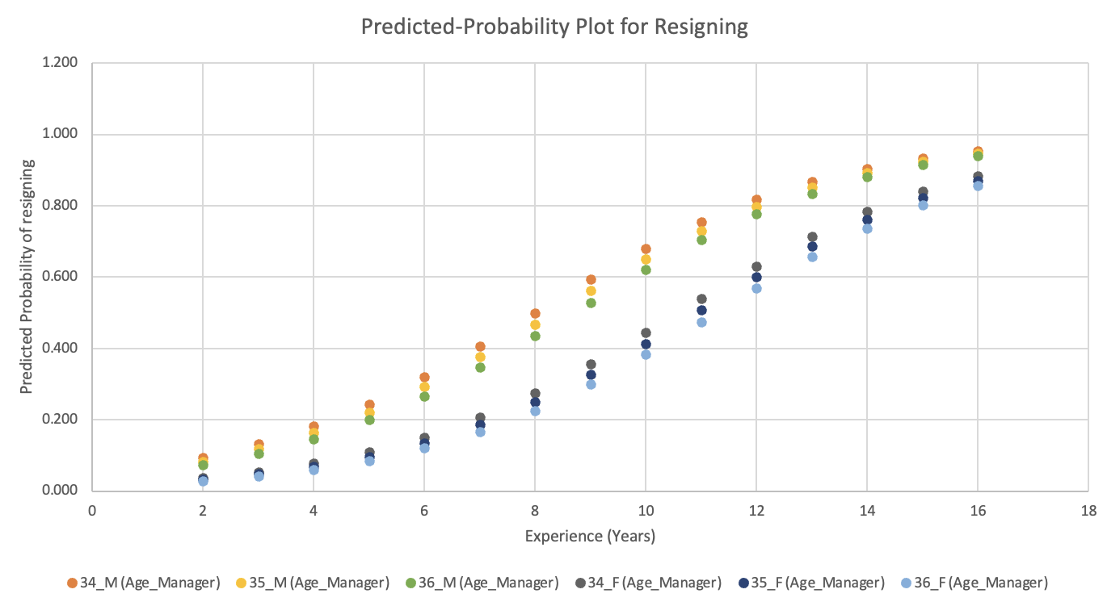
Figure 2. Predicted-Probability Plot for Resigning
Figure 2 shows predicted probabilities of store managers resigning based on three variables: age, experience, and gender.
Effect of Age:
- Within the same gender and age group from 34 to 36, probability of resignation is inversely proportional to manager age. This effect is consistent in both gender group but not significant across age group.
Effect of Experience:
- Resignation predicted-probability increases as experience increases across all age group for both gender, more noticeably for males.
Effect of Gender:
- Male managers show a higher probability of resigning than female manager, particularly as they gain more experience.
Recommendation:
- Implement regular reviews and support mechanisms, particularly for experienced managers, as they show higher probabilities of resigning. This could include career development programs, mentoring, and enhanced job satisfaction.
- Develop tailored strategies for male managers, addressing their higher resignation probabilities through flexible working conditions, improved work-life balance, and career progression support.
- Forcasting Production
The objective is to forecast the future sales volumes of Pale Ale for the next 4 quarters. A multiplicative time-series model was chosen because it's particularly effective for data with seasonal variations that are not constant over time. The model was adapted to exclude cyclical components due to the absence of longer-than-yearly fluctuations or business cycles in the provided data, focusing instead on capturing trend and seasonal patterns.
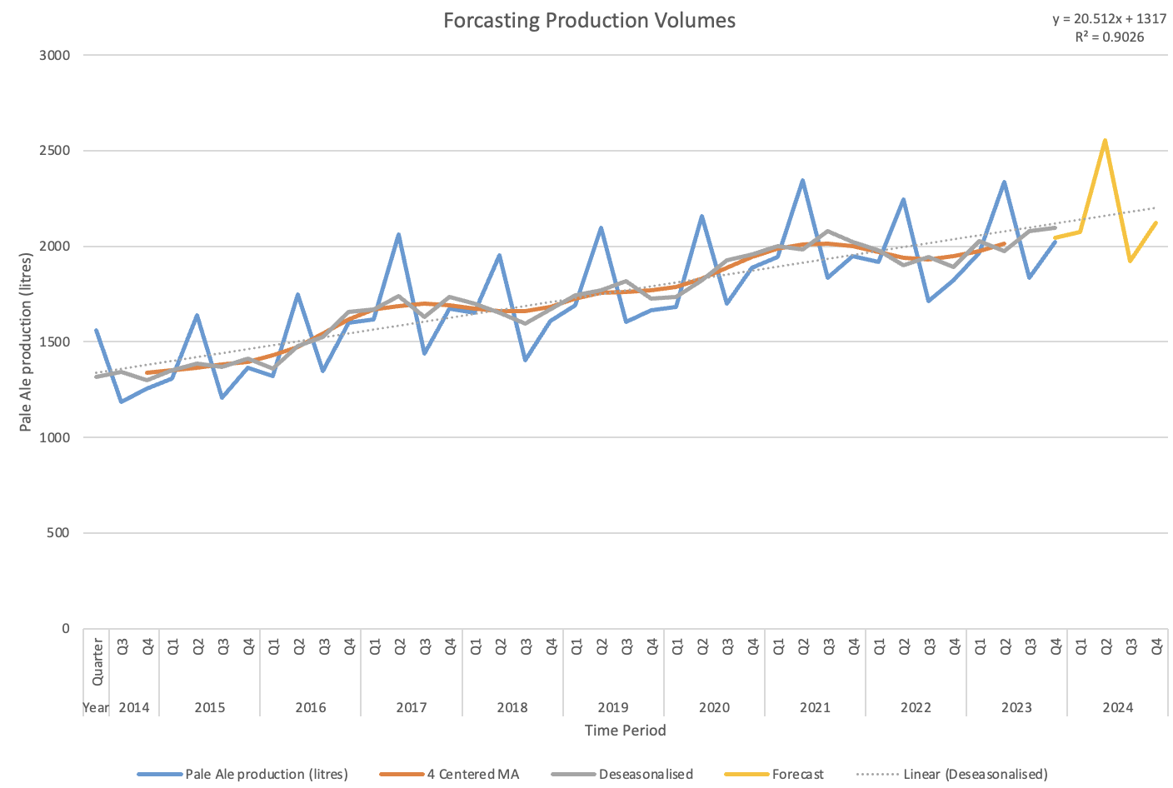
Figure 3. Forcasting Production Volumes
- Trend:
  - Pale Ale production exhibits a clear seasonal pattern, with peaks typically in the third quarter of each year. This could be tied to specific market demands or operational cycles.
  - The trend component is derived from a deseasonalized series, representing the long-term movement in sales data.
  - A linear regression on the deseasonalized data shows a significant fit (R² = 0.9026), indicating a robust upward trend in sales volume over time.
- Seasonal indices calculated from the data reflect specific quarterly patterns.
  - Q1: 3.5% below annual average
  - Q2: 3% below annual average
  - Q3: 18.3% above annual average
  - Q4: 11.8% below annual average.
- Multiplicative Forecast: Final forecasts are produced by multiplying the estimated trend values by the seasonal indices for corresponding quarters:
  - 2024-Q2: 2073.53 litres
  - 2024-Q3: 2553.6 litres
  - 2024-Q4: 1921.03 litres
  - 2025-Q1: 2121.57 litres
Model Performance:
- MAPE: 3.66%, indicating that, on average, the forecasted values deviate from the actual values by 3.66%. This low error rate suggests high accuracy and reliability in the model's predictions.
The multiplicative time-series model effectively forecasts future Pale Ale sales by accurately capturing and projecting the inherent seasonal patterns and overall trend of the data. This model serves as a valuable tool for strategic planning, offering reliable insights that can help optimize production, inventory management, and marketing efforts to align with anticipated sales volumes.
CONCLUSION
The models developed across these tasks provide valuable insights into sales dynamics, promotional strategies, customer behaviors, employee turnover, and production planning. These insights not only enhance understanding but also support strategic decision-making, allowing businesses to tailor their strategies based on predictive analytics. Future work will focus on refining these models with additional data and advanced modeling techniques to improve accuracy and reliability, ensuring that the models remain robust in changing market conditions.

APENDIX A
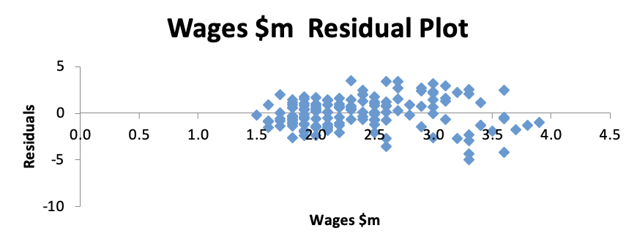
Figure 4. Wages Residual Plot
Figure 4 does not display any clear pattern, indicating that the relationship between Wages and Sales Revenue might be appropriately modeled as linear.
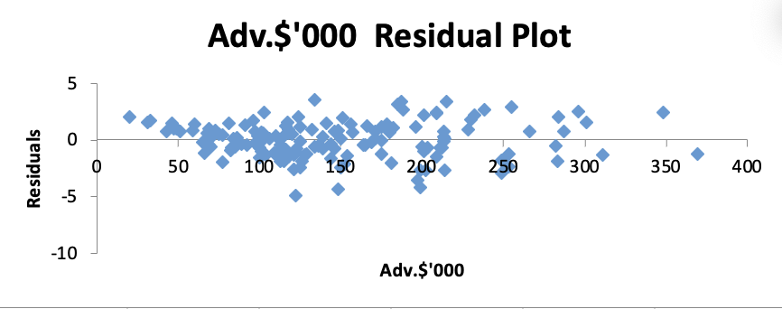
Figure 5. Advertising Residual Plot
Figure 5 shows that the residual plot spreads fairly randomly around the zero line, which suggests linear relationship between Advertising Spend and Sales Revenue.
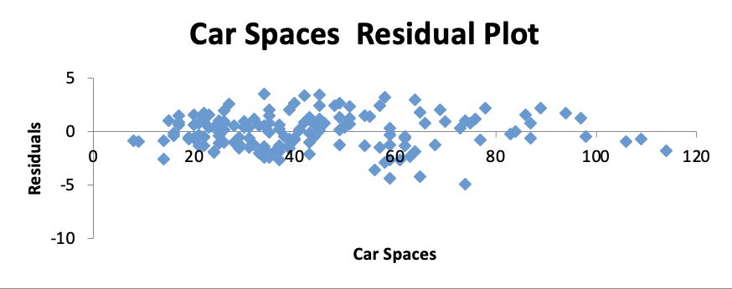
Figure 6. Car Spaces Residual Plot
Figure 6 show a random dispersion around the zero line, which suggests linear relationship between Car Spaces and Sales Revenue.
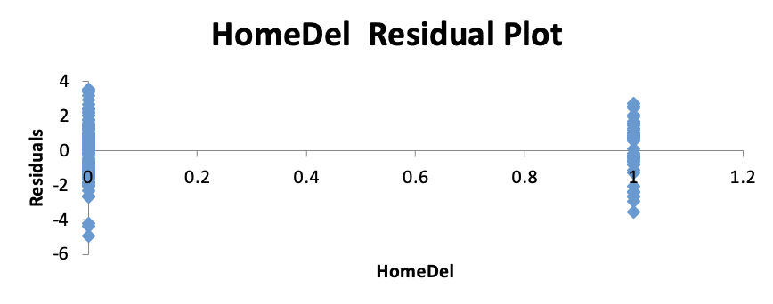
Figure 7. Home Delivery Residual Plot
Figure 7 shows very distinct pattern, with residuals highly concentrated at specific points due to the nature of Home Delivery data.
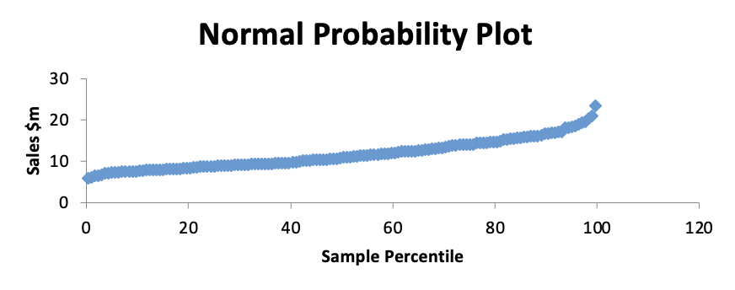
Figure 8. Normal Probability Plot
Figure 8 shows a fairly straight line, suggesting that the residuals are normally distributed.

